|  |  |
| --- | --- |
| **Name:** | Keerti P. Charantimath |
| **Roll Number:** | 19MA20059 |

**BJT-CE CHARACTERISTICS**

1. **Aim of the experiment:**
   * To understand the structure and operation of a Bipolar Junction Transistor and study Common-Emitter characteristics of a BJT.
2. **Tools used:** 
   * Resistors
   * Ammeters
   * Voltameters
   * Connecting Wires
   * Transistor
   * Power Source
3. **Background knowledge:**
   * A **Bipolar Junction Transistor is a three-terminal semiconductor device consisting of two p-n junctions** which are able to amplify or magnify a signal. It is a current controlled device. The three terminals of the BJT are the base, the collector and the emitter.
   * BJTs can be made either as PNP or as NPN.

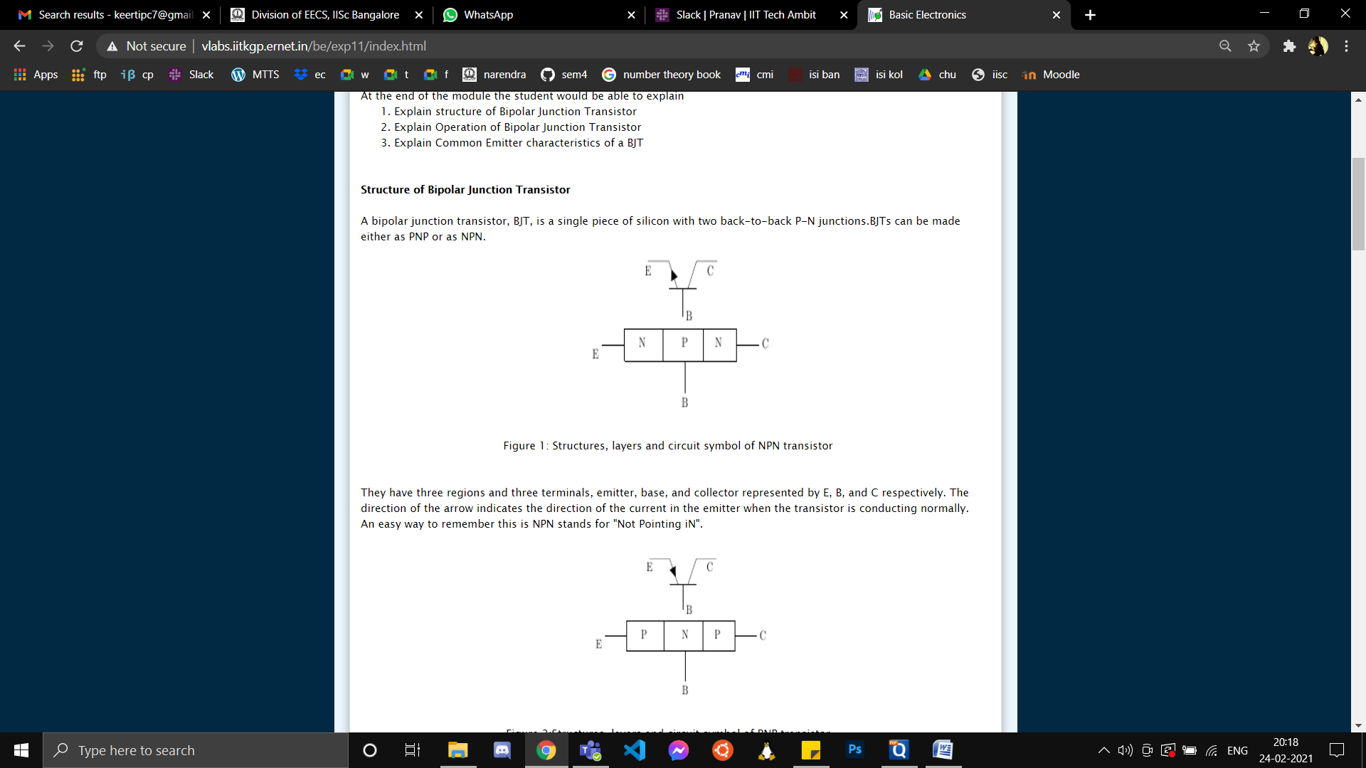

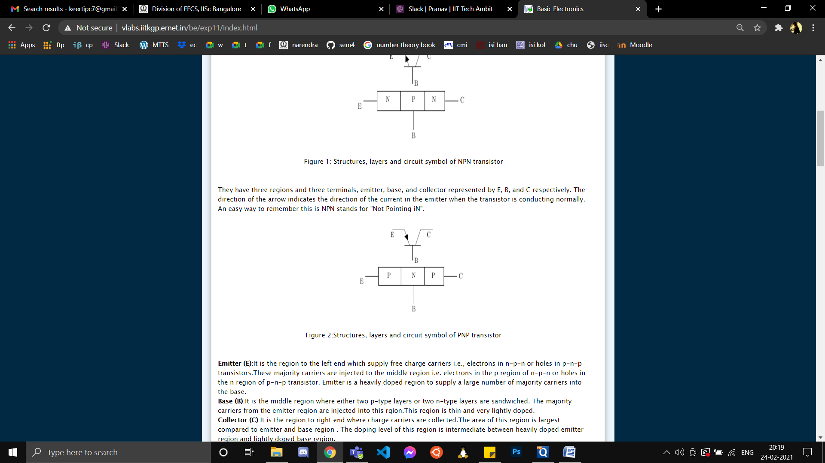

* + **Emitter**- It is the region to the left end which **supply free charge carriers** i.e., electrons in npn or holes in pnp transistors. These majority carriers are injected to the middle region i.e. “base”.
  + **Base** – The middle section of the transistor is known as the base. The base forms two circuits, the input circuit with the emitter and the output circuit with the collector. The emitter-base circuit is in forward biased and offered the low resistance to the circuit.
  + **Collector**- The right most region is known as collector. The role of the collector region is to **collect or attract current carriers injected in the base region** of the transistor.
  + A BJT is said to be operational only in **Forward Active Mode** where the BE junction is in forward bias and CE junction is in reverse bias for a npn transistor.
  + The BJT is said to have **Common Emitter** (CE) configuration, when the emitter terminal is grounded (i.e. the emitter is made common to the input and output).
  + Hence, the **input is between the base and the emitter** while the **output is between the collector and the emitter.**
  + **Input characteristic** – the [variation](https://www.toppr.com/guides/fundamentals-of-business-mathematics-and-statistics/algebra/variation/) of the base current (IB) with the base-emitter voltage (VBE)
  + **Output characteristic** – the variation of the collector current (IC) with the collector-emitter voltage (VCE)

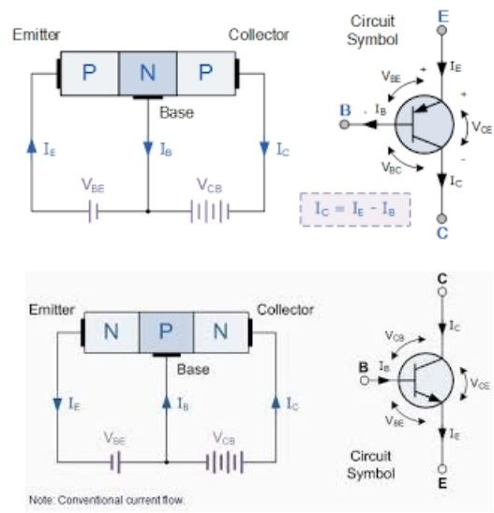

Here, IE is the emitter current, IC is the collector current, and IB is the base current.

* In case of NPN transistor in CE configuration, BE junction is forward biased, so IE comes out of the transistor, while IC and IB come into the transistor, and vice versa in case of PNP transistor. It is proved that IE = IC + IB in all the cases.
* Here IC = α.IE = β.IB, where β = current gain of the CE (Common Emitter) configuration and α = current gain of CB (Common Base) configuration. Here, α= β/1+ β So, β= α/1−α
* Here, α has a value slightly less than unity, so, IC ≈ IE and IB ≈ 0, β has a very large value as seen from the equation. So, current gain in a CE configuration is very high.

1. **Circuit (hand drawn/image):**
   * **BJT CE Input Characteristics**

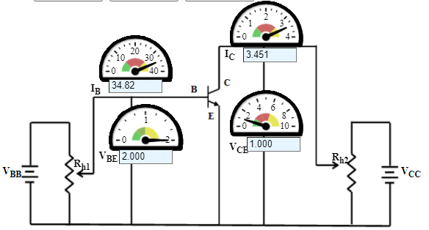

* + **BJT CE Output Characteristics**

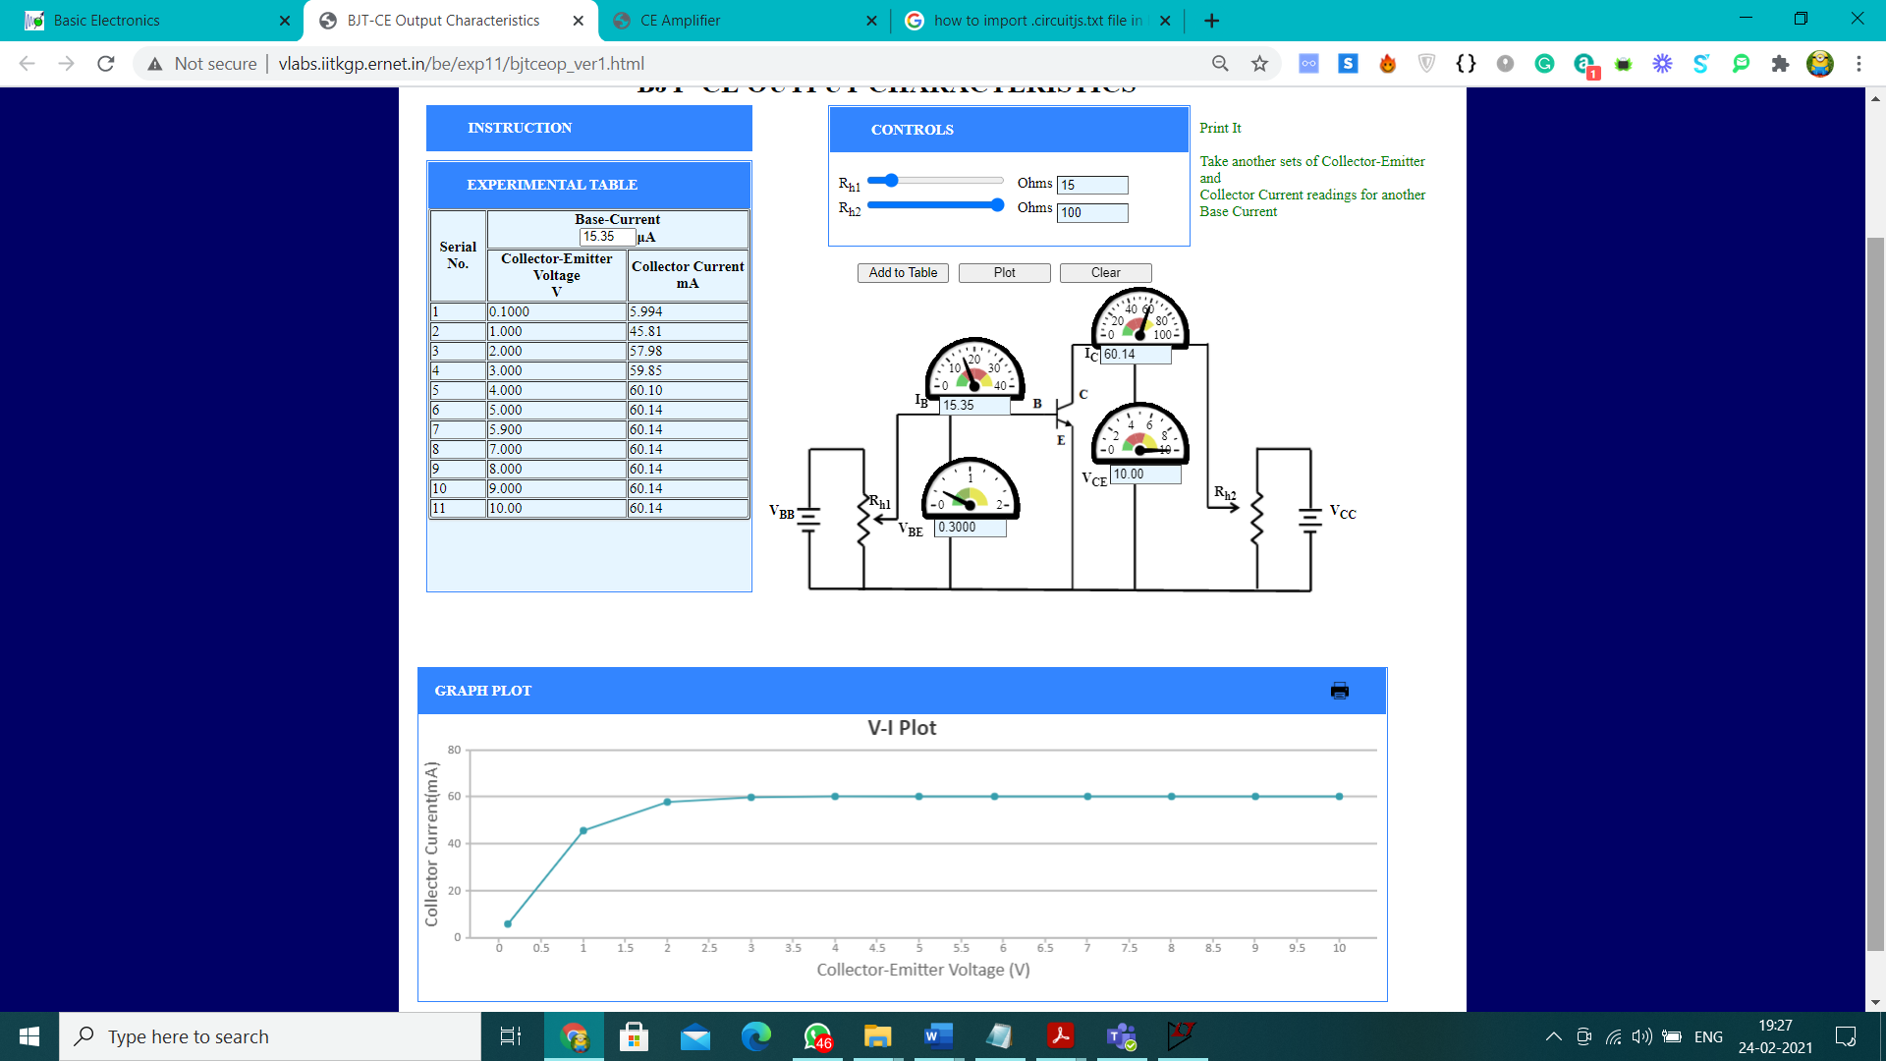

1. **Measurement Table:**
   * **BJT CE Input Characteristics**

|  |  |  |
| --- | --- | --- |
| **Serial No.** | **Base-Emitter Voltage V** | **Base Current μA** |
| 1 | 0.02000 | 2.058 |
| 2 | 0.2000 | 2.661 |
| 3 | 0.4000 | 3.542 |
| 4 | 0.6000 | 4.713 |
| 5 | 0.8000 | 6.271 |
| 6 | 1.000 | 8.345 |
| 7 | 1.200 | 11.11 |
| 8 | 1.400 | 14.78 |
| 9 | 1.600 | 19.67 |
| 10 | 1.800 | 26.17 |
| 11 | 2.000 | 34.82 |
| 1 | 0.02000 | 2.058 |
| 2 | 0.2000 | 2.661 |
| 3 | 0.4000 | 3.542 |
| 4 | 0.6000 | 4.713 |

* + **BJT CE Output Characteristics**

|  |  |  |
| --- | --- | --- |
| **Serial No.** | **Collector-Emitter Voltage V** | **Collector Current mA** |
| 1 | 0.100 | 5.994 |
| 2 | 1.000 | 45.81 |
| 3 | 2.000 | 57.98 |
| 4 | 3.000 | 59.85 |
| 5 | 4.000 | 60.10 |
| 6 | 5.000 | 60.14 |
| 7 | 5.900 | 60.14 |
| 8 | 7.000 | 60.14 |
| 9 | 8.000 | 60.14 |
| 10 | 9.000 | 60.14 |
| 11 | 10.00 | 60.14 |

1. **Graph (Image)/Screenshots**
   * **BJT CE Input Characteristics**

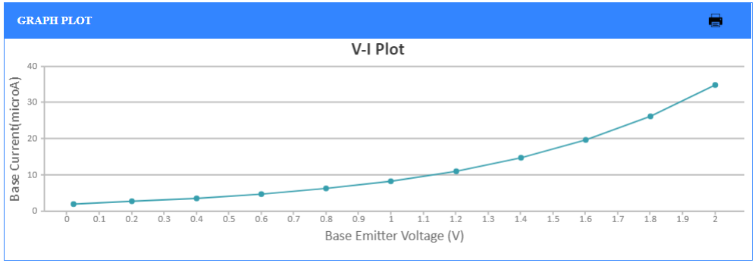

**Graph of IB v/s VBE**

* + **BJT CE Output Characteristics**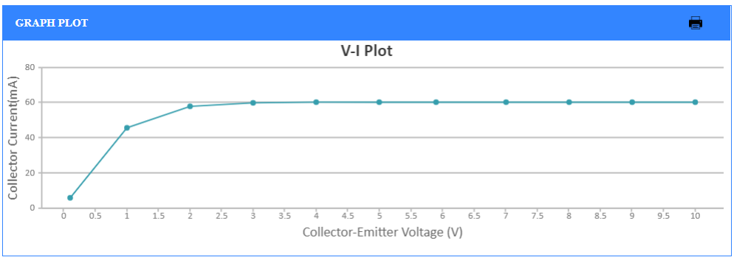

**Graph of IC v/s VCE**

1. **Conclusion:**

* **BJT CE Input Characteristics**
* As the base Base-to-Emitter voltage increases and Collector-to-Emitter voltage is kept constant, we observe from the graph that the base current also increases.
* The curve for common base configuration is similar to a forward diode characteristic.
* Due to forward bias, the emitter-base junction acts as a forward biased diode. Therefore, the width of the depletion region at the emitter-base junction is very small and electrons (in npn transistor) can easily cross the base-emitter junction.
* **BJT CE Output Characteristics**
* We observe from the graph that the Collector Current increases with Collector-to-Emitter voltage till certain extent and becomes constant after a point.
* The region in which the Collector Current increases with Collector-to-Emitter voltage is known as the **Saturation region.**
* The region in which the Collector Current is constant is known as the **Forward Active Region.**
* The Collector-to-Emitter Voltage at which the Collector Current becomes constant is known as **Saturation Voltage** which is generally ranges from 0.2V to 0.4 V**.** Saturation Voltage for the given BJT CE transistor is 5V(approx.)

1. **Discussions:**

* The Emitter region is highly doped as the rate of diffusion of electrons in an npn transistor from emitter to base is dependent on the amount of doping of the emitter.
* The Base region is lightly doped as we do not require too much hole injection from base to emitter in an npn transistor.
* The Collector region is moderately doped as we don not want a crowd of electrons in the collector of npn transistor as it may result in repelling of the electrons coming from the Emitter-Base path and decrease in collector current.
* For a transistor to work as an amplifier, we need to ensure that it is biased in the forward active region. Else we would get a clipped output waveform which is not a desired output for an amplifier.
* The CE configuration provides both High Current and Voltage gain unlike other configurations like CC (High current gain but voltage gain less than unity i.e. 1) and CB (High voltage gain but current gain less than unity).
* Thus CE configuration is best for amplification because of its high power gain (due to its both high voltage and current gain) and hence most widely used.

**BJT CE AMPLIFIER**

**(Simulated on Lt-Spice)**

1. **Aim of the experiment:**
   * To study Bipolar Junction Transistor in common emitter configuration as a voltage amplifier
   * To measure the signal handling capacity.
   * To observe the frequency response of the circuit.
2. **Tools used:** 
   * Voltage source (AC and 12VDC)
   * Resistances (68k x1,47k x 1,4.7k x1,1k x1, 330 x2)
   * Voltmeter
   * Ammeter
   * N-P-N transistor
   * Capacitor (10mF x2, 100mF x1)
   * Connecting wires
3. **Background knowledge:**
   * The common emitter BJT configuration is commonly used as a basic amplifier as it has both voltage and current amplification properties. This network's function is to provide necessary bias conditions to ensure that the emitter-base (EB or BE) junction of the transistor operates in the active region and remains near the Q point. A basic BJT common emitter amplifier has a very high gain that may vary from one transistor to another. In the circuit, the base terminal is the input, the collector terminal is the output, and the emitter is common. Thus, it is a voltage amplifier with an inverted (out-of-phase) output.



* **Coupling capacitor -** To have a noiseless amplified transmission of a signal (without DC), it is necessary to block the DC part so that it does not enter the amplifier or load. This is done by inserting a coupling capacitor between the two stages.
* **Bypass capacitor -** The addition of RE in the circuit causes decreased amplification at higher frequencies. Thus, to avoid this effect, a capacitor is bypassed so that it blocks DC but acts as a short circuit for AC. Therefore capacitor is connected in parallel with the emitter resistance RE.
* **Frequency Response of Common Emitter BJT Amplifier -**
  + The voltage gain of a CE amplifier varies with the signal frequency. This is mainly because of the capacitor's reactance change along with signal frequency, which affects the output voltage.
  + Bypass capacitors connected to the emitter are used to short circuit the emitter resistor, increasing the gain at high frequencies. The coupling (blocking) and bypass capacitors cause the fall of the signal in the amplifier's low-frequency response, as their impedances become very large at low frequencies. The stray capacitances behave like open circuits.
  + In the mid-band frequency range, large capacitors are short circuits and the stray capacitors are open circuits. Thus no capacitance appears in the mid-frequency range. The mid-band frequency gain is maximum.
  + At the high frequencies, the bypass and coupling capacitors are short circuits. The stray capacitors and the transistor operation determine the corresponding response.



* Mid-band gain is calculated from the equivalent AC circuit using the following formula:





**DC Analysis**

1. **Circuit Diagram:**

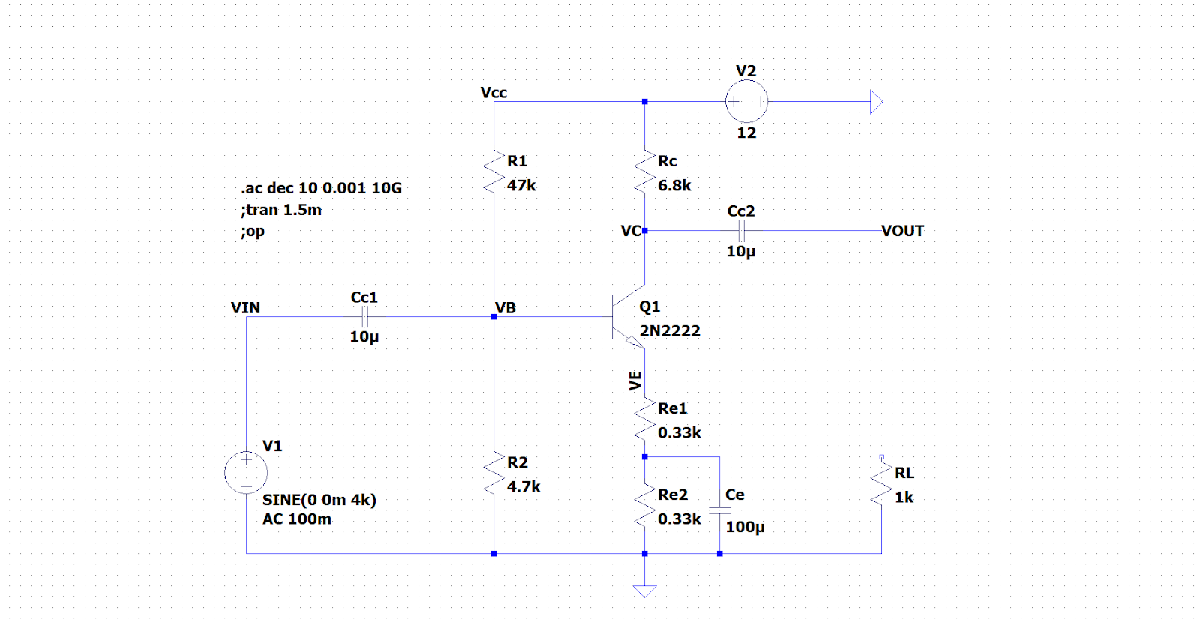

AC source is disconnected and DC supply is set to 12 V to find the operating point values:  
Vc = 7.54006V, Vb = 1.07772, Ve = 0.43491  
Ic = 0.6558mA, Ib = 3.0866uA, Ie = 0.65896mA

1. **Observations:**

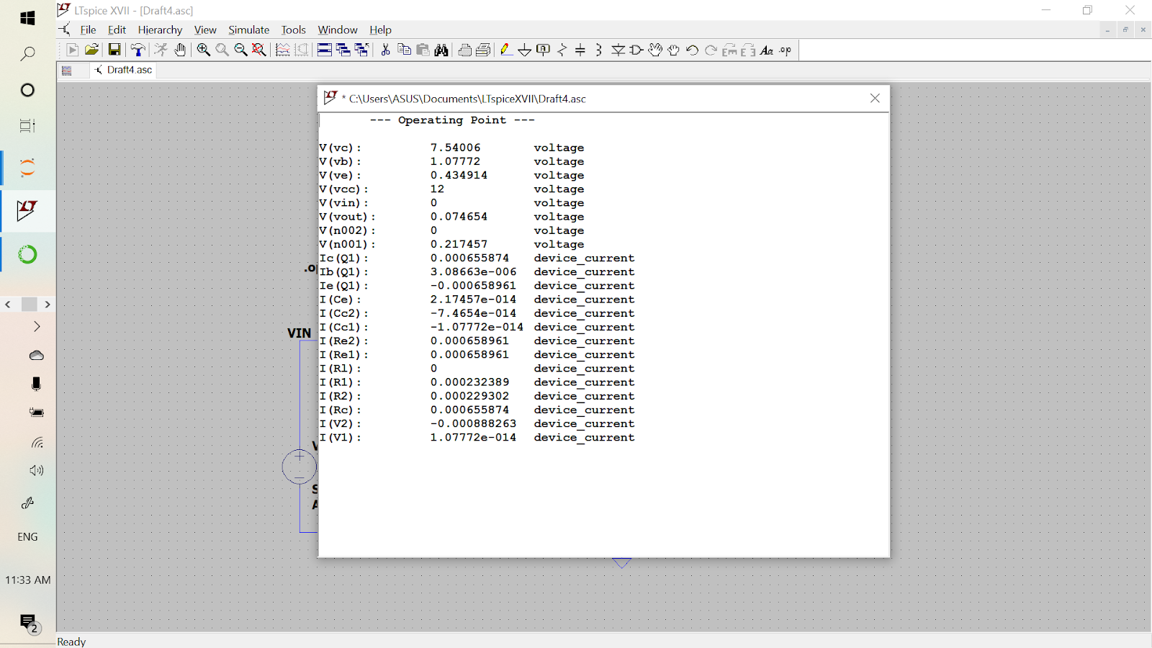

Figure represents the operating point determined from Lt-spice.

**Signal Handling Capacity**

Initially a 100mV 4kHz signal is provided to the circuit and its output signal is observed.  
We then increase the voltage of the input in steps until we see noticeable distortion in the output waveform.  
We take this maximum voltage value of the input value before distorting and name it Vsm.

1. **Load Disconnected:**

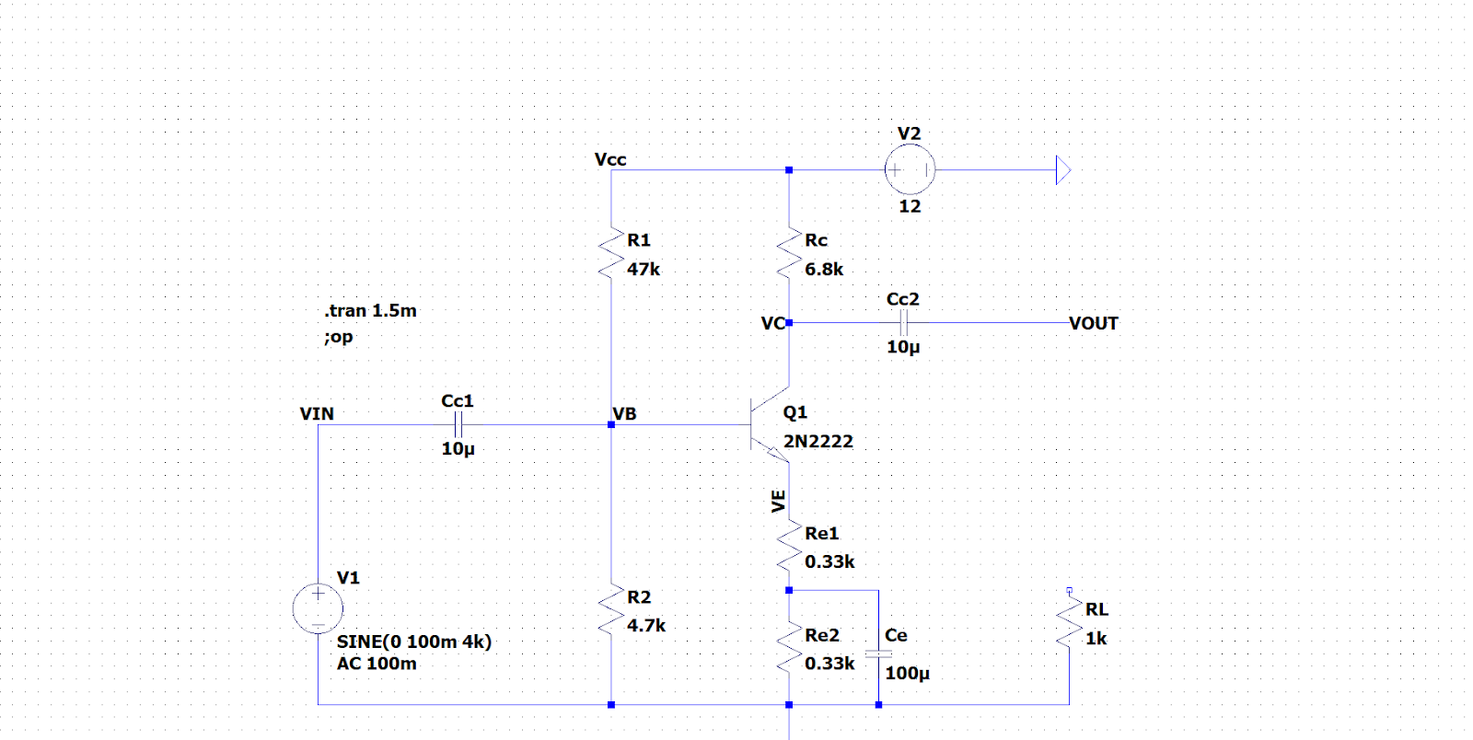

This is the input and the output waveform plotted for an input peak voltage of 100mV and disconnected load case.   
We observe that the output positive peak voltage is 1.8V and the sine wave is undistorted.

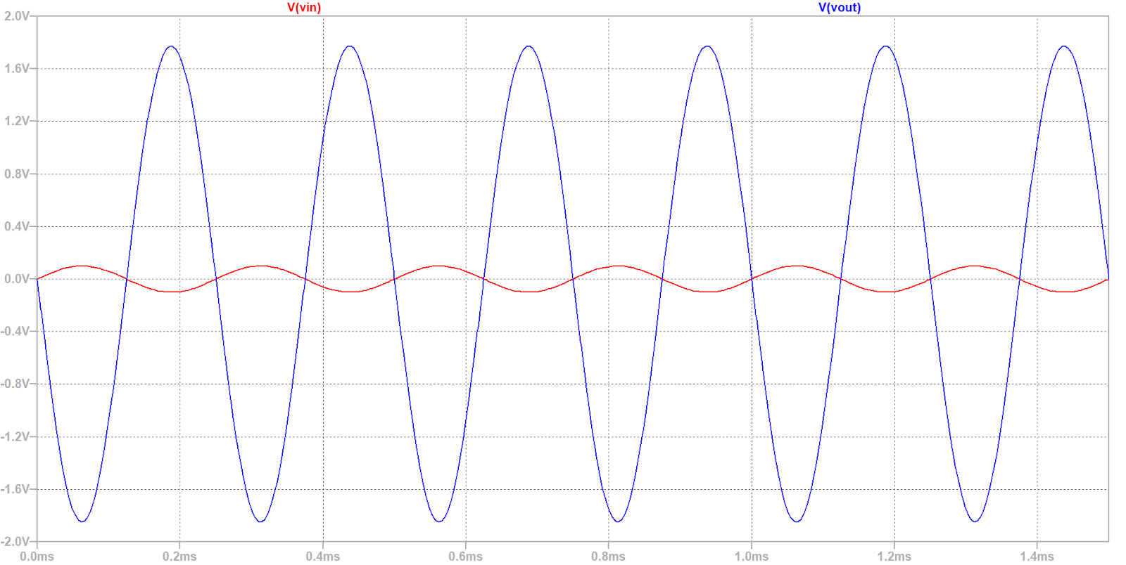

We now increase the input peak voltage in steps and observe the shape of the output waveform.

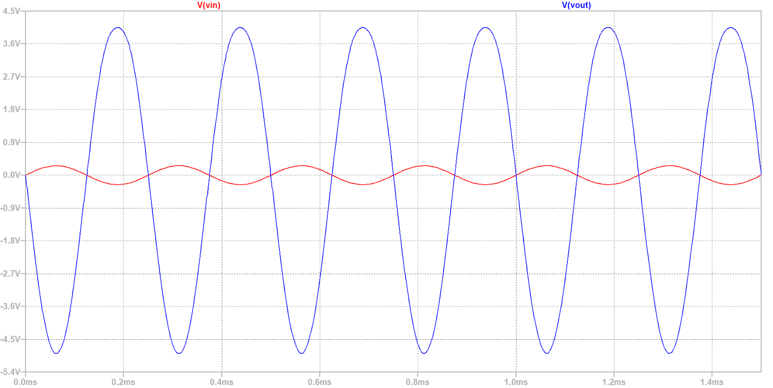

This is the output waveform for an input peak voltage of 250mV after this point we start noticing the distorted shape of the output waveform. Hence Vsm = 230mV  
Peak positive output voltage at Vsm is approximately 4V

1. **Load Connected:**

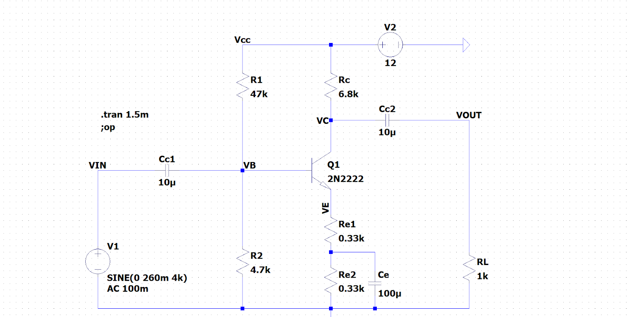

For the load connected case the voltage amplification will be considerably smaller.  
The Vsm for this case is observed to be around 260mV.  
We observe that at Vsm the positive peak voltage for the output is just about 500mV which is considerably smaller than 4 volts in no load connected connection.

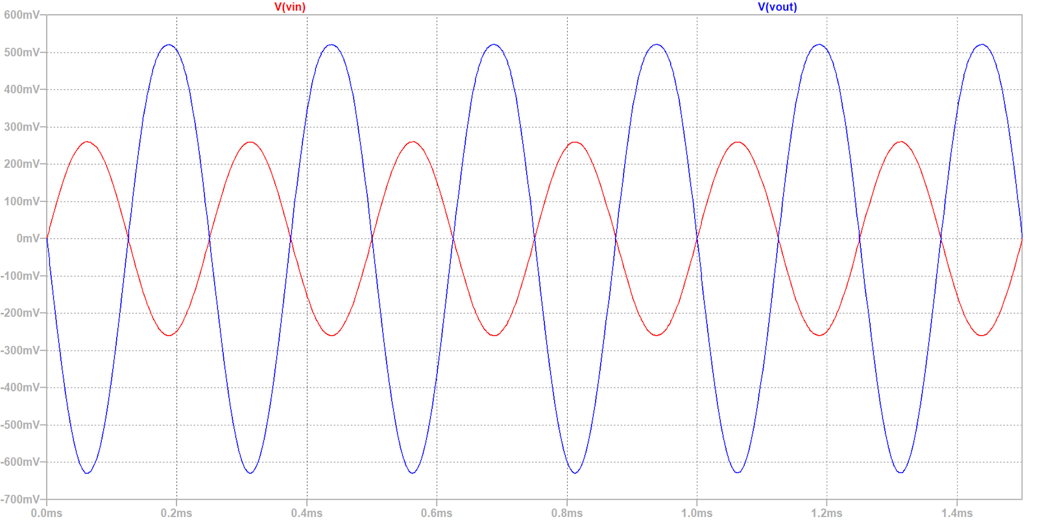

**Frequency Response**

1. **Load Disconnected:**

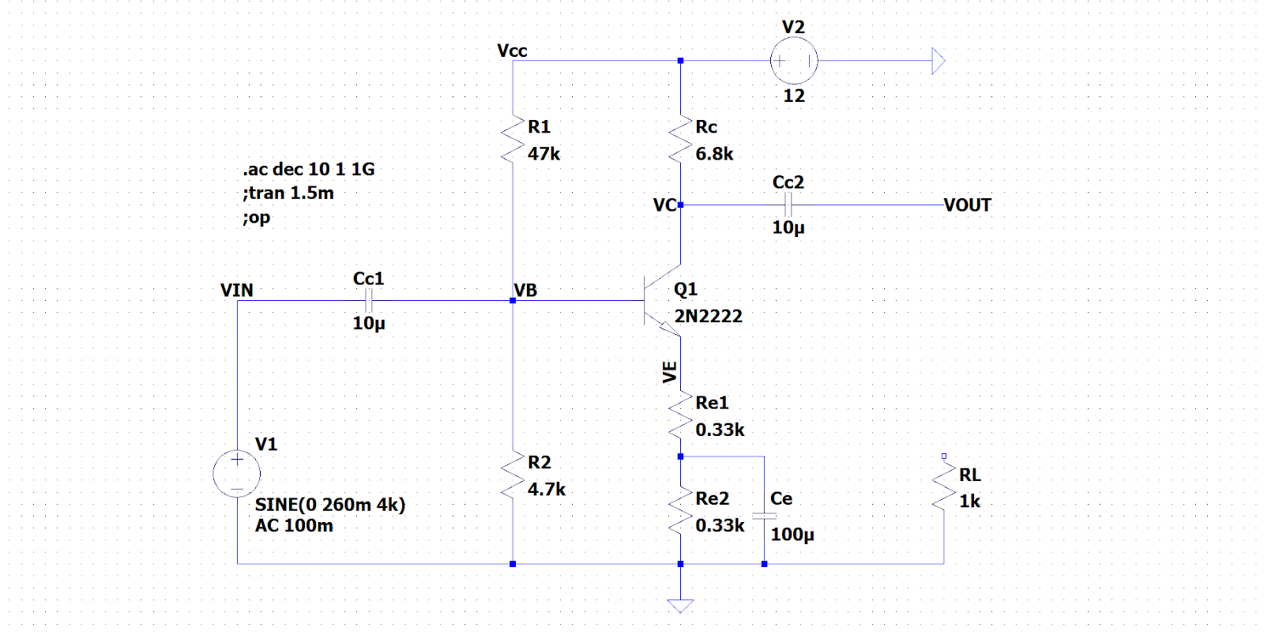

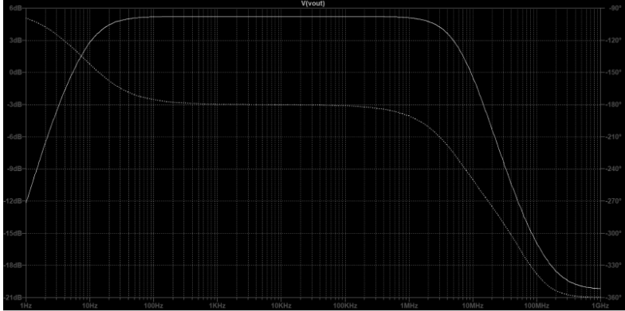

Lower cutoff frequency = 8.5Hz

Higher cutoff frequency = 6.2MHz

1. **Load Connected:**

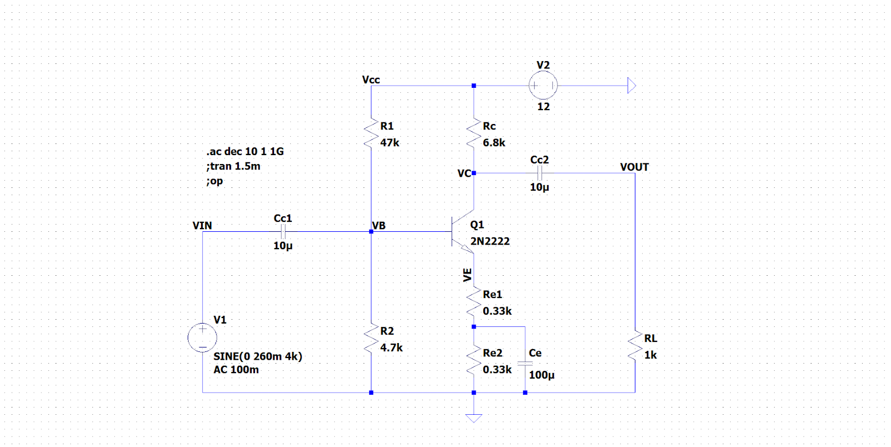

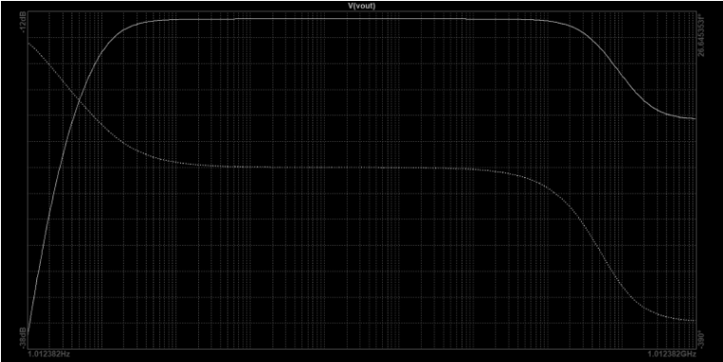

Lower cutoff frequency: 8.7Hz

Higher cutoff frequency:70MHz

1. **Effect of Ce(Disconnected):**

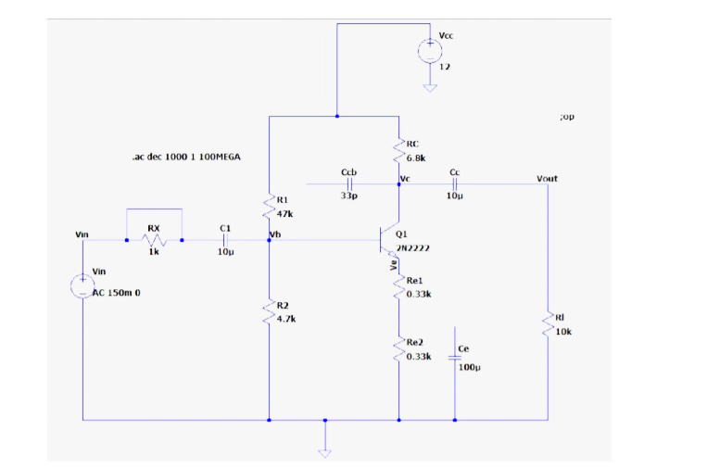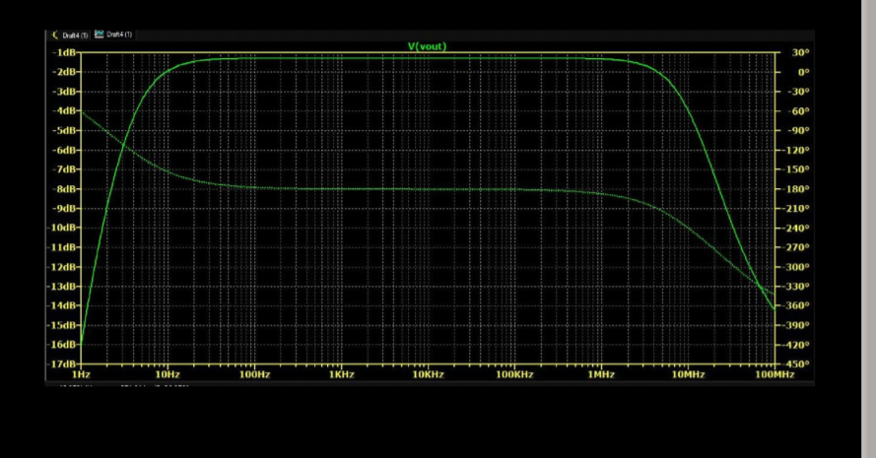

Lower cutoff frequency: 4.061Hz

Higher cutoff frequency:10.561MHz

1. **Miller Effect(Re1 and Re2 bypassed):**

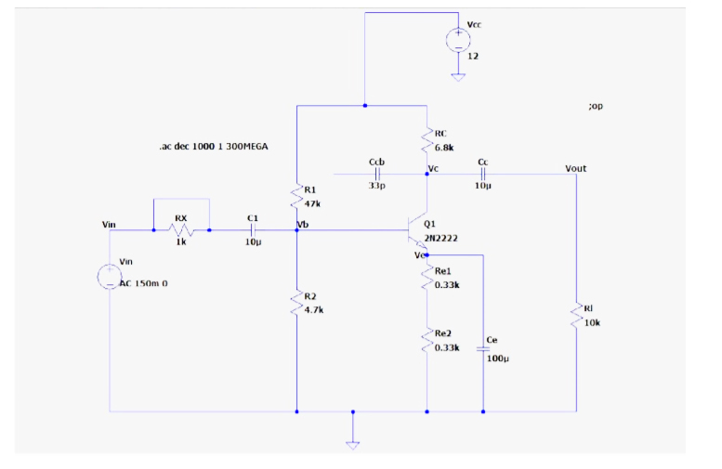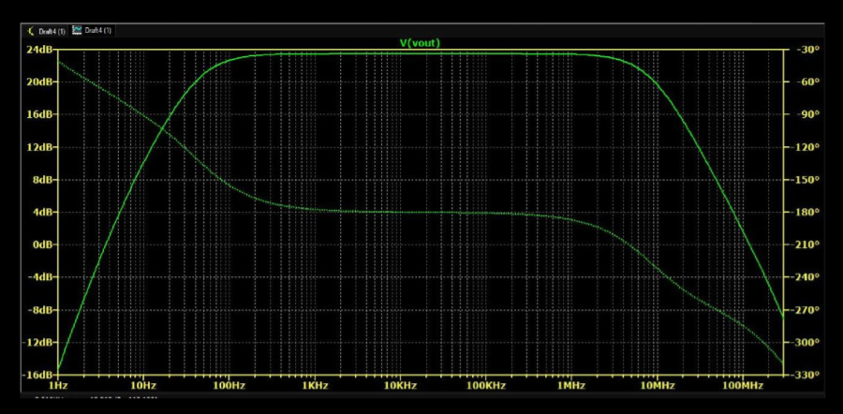

Lower cutoff frequency: 49.256Hz , Higher cutoff frequency:9.257MHz

1. **Conclusion:**
   * Maximum mid-band gain without load = **26.8716 dB**, at frequency= **53149 Hz**
   * Maximum mid-band gain with load = **24.3864 dB**, at frequency= **40329 Hz**
   * Lower cutoff frequency with load = **8.7 Hz,**Higher cutoff frequency with load = **70MHz**
   * Lower cutoff frequency without load = **8.5Hz,**Higher cutoff frequency without load= **6.2MHz**
   * Lower cutoff frequency with Ce disconnected = **4.061Hz**,Higher cutoff frequency with Ce disconnected = **10.561MHz**
   * Lower cutoff frequency(Miller Effect)= **49.256Hz**,Higher cutoff frequency(Miller effect):**9.257MHz**
   * The signal handling capacity as measured from our experiment is approximately for disconnected load is 230mV and connected load is 260mV.
   * In no load connected circuit, the peak amplified current measured before distorting the signal was approximately 4V.
   * While the load was connected the peak voltage obtained was approximately 500mV which is considerably lower than in no load condition.
   * In frequency response analysis for no load condition, the bandwidth observed was about 6MHz. The lower cutoff frequency is about 8 Hz, and the higher cutoff frequency is about 6.2MHz
   * For the load-connected case, in frequency response analysis, the bandwidth observed comes out to be 70MHz. The lower cutoff frequency being around 8 Hz and the higher cutoff frequency being around 70MHz.
   * The gain in no load case is considerably higher than in load connected case.
2. **Discussions:**
   * While performing DC Analysis, we used a DC source of 12V connected to Vcc to obtain voltages Ve, Vb, Vc at the DC operating point by performing the. op simulation command.
   * In the transient analysis, we used a 4kHz AC sine wave source then observed the input and output waveforms within a time frame of 1.5ms. The output waveforms appear to be significantly amplified and inverted as compared to input waveforms.
   * For observing the frequency response, we used an AC source of 100mV(<260mV = Vsm ) with a frequency ranging from 1 Hz to 10GHz. As we expected, the gain increases steadily at first, then remains almost constant for an extensive range, and then falls off steadily again at very large frequencies.
   * From the above graph, we observe that the voltage gain drops off at low (< FL) and high (> FH) frequencies, whereas it is constant over the mid-frequency range (FL to FH).
   * At low frequencies (< FL), the reactance of the coupling capacitor C2 is relatively high, and a hence tiny part of the signal will pass from the amplifier stage to the load.
   * Moreover, CE cannot shunt the RE effectively because of its large reactance at low frequencies. These two factors cause a drops off in voltage gain at low frequencies.
   * At high frequencies (> FH), the reactance of the coupling capacitor C2 is very small, and it behaves as a short circuit. This increases the loading effect of the amplifier stage and serves to reduce the voltage gain.
   * Moreover, at high frequencies, the base-emitters junction's capacitive reactance is low, which increases the base current. This frequency decreases the current amplification factor β. Due to these two reasons, the voltage gain drops off at a high frequency.
   * At mid frequencies (FL to FH), the voltage gain of the amplifier is constant. The coupling capacitor C2 in this frequency range is such as to maintain a constant voltage gain. Thus, as the frequency increases in this range, the reactance of CC decreases, which tends to increase the gain.
   * However, at the same time, lower reactance means higher, almost cancel each other, resulting in a uniform fair at mid-frequency.
   * **Properties of CE Amplifier:**
     + Large current gain, voltage gain and power gain.
     + Current and voltage phase shift of 180 degrees.
     + Moderated output resistance.
   * **Applications of CE Amplifier:** Common Emitter amplifier configuration is widely used due to its advantage of moderate current and voltage gain:
     + It is used in Audio Amplifiers
     + It is used in Microphones, Music Players
     + It is used in the Frequency generation circuit to increase the strength of the input signal.
     + It is used to increase the speed of Fans, Motors, and Timer circuits.
     + Common-emitter amplifiers are also used in radio frequency transceiver circuits.
     + Common emitter configuration is commonly used in low-noise amplifiers.